ATLANTIC CHRISTIAN ACADEMY
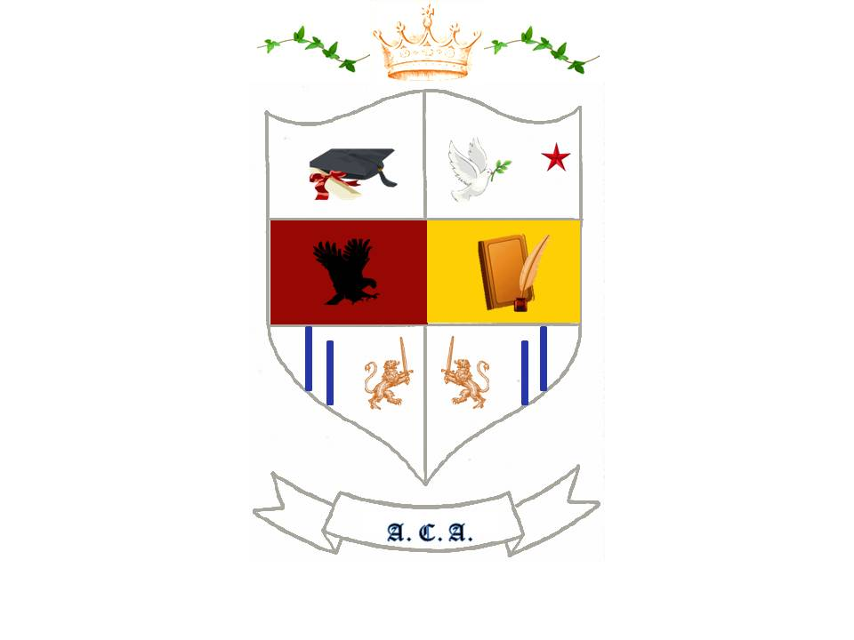
Providing Educational Excellence Since 2008
www.Atlanticchristianacademyhs.org
admin@AtlanticChristianAcademyhs.org

OFFICIAL TRANSCRIPT AUTHORIZATION FORM

For Official Transcript request you have to complete the following information.
We provide ONLY Official Transcript in original, sealed with envelope. We don't provide copies. The Fee for each Official Transcript is $35.00. Original Diplomas is $55.00.
This process take 7-10 working days.

COMPLETE THIS INFORMATION AND SEND IT BACK

Student Name: _______________________________________________________________

Student Address: ______________________________________________________________

Last Digit of your Social Security No.: _______ Driver License No: _______________________

DOB: ___________________ Phone: ____________________ Cellular: __________________

School Name: _______________________________ Location: _________________________

Do you have any transcript? _______ Please send copy of your transcript

Do you have your Diploma? ______G.P.A.: _________ GRADUATION DATE: ____________

Type of Payment: VISA____ MASTER CARD ____DISCOVER ____CASH_____CHECK_____

AMOUNT: $_____________ Payment for: Transcript ____ Diploma ______

Signature: _________________________________________ Date: ___________________

For Official Use Only

Approval Code:________ Order: ______ Batch: _____ Date _________ Sch: ________

