Happy Labor Day Celebration

You have worked hard
toiling throughout delivering your best
now it’s time to relax
have some rest
best wishes on Labor Day 2016 !!
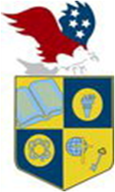
ATLANTIC
CHRISTIAN ACADEMY
is an independent, international autonomous
global high school institution
Serving students since 2006
Owned and Operated by Teachers
http://www.atlanticchristianacademyhs.org

admin@atlanticchristianacademyhs.org

https://www.facebook.com/Atlantic-Christian-Academy-389351357794934

