ATLANTIC CHRISTIAN ACADEMY
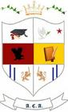
Independent, international autonomous global high school institution
​Providing Educational Excellence Since 2006

www.atlanticchristianacademyhs.org
admin@atlanticchristianacademyhs.org

God bless you with the gentle spirit Christmas brings and all the seasons’ special things! May the joy and peace of Christmas be with you today and always.

Merry Christmas
&
Happy New Year 2017

